1. Solving problems using array functions on rest countries data.
   1. Get all the countries from Asia continent /region using Filter function

Code:

var sum = obj.filter((x)=>{

if(x.region ==="Asia")

console.log(x.name)}

);

Output:

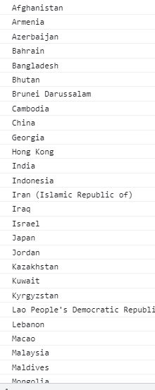

* 1. Get all the countries with a population of less than 2 lakhs using Filter function

Code:

  var sum = obj.filter((x)=>{

if(x.population < 200000)

console.log(x.name)}

);

Output

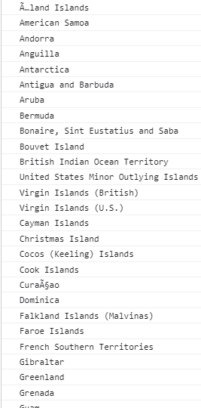

* 1. Print the following details name, capital, flag using forEach function

Code

obj.forEach((x)=>{

      for(var key in x){

         console.log(x.name, x.capital, x.flag);

       }

       });

Output

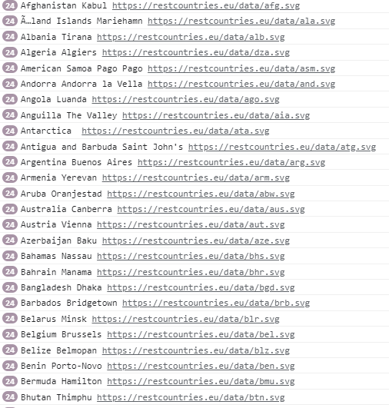

* 1. Print the total population of countries using reduce function

**code**

var s=obj.map((x)=>{

return x.population;

})

.reduce((first,second)=>first+second);

console.log(s);

Output:

7349137231

* 1. Print the country which uses US Dollars as currency.

**code**

var s=obj.filter((x)=>{

if(x.currencies.code==="USD")

return x.name;

})

console.log(s);

Output:

[] – No data found. If found please tell me correct coding in comment